Analyze Phase Report

Improving Gummy Packaging Efficiency

Beak & Skiff's Ayrloom Facility

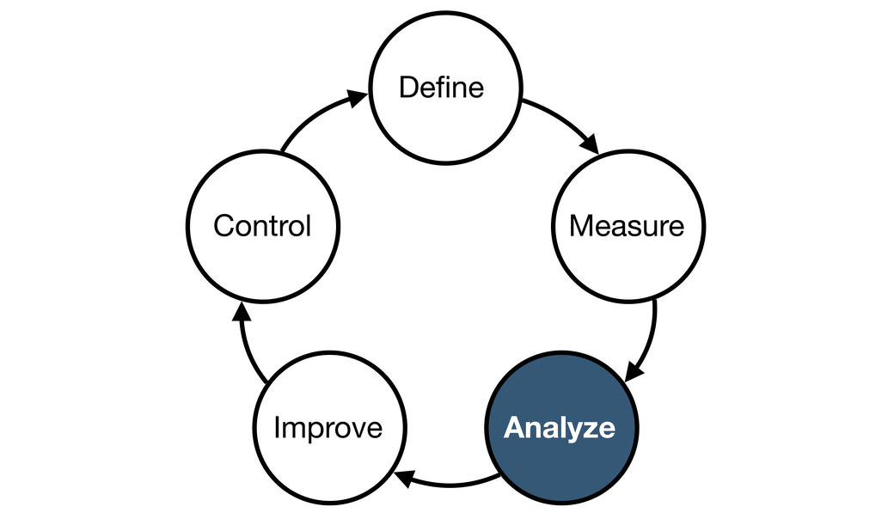

1. Introduction
As part of our Lean Six Sigma project for SCM 755 at Syracuse University, the team was tasked with identifying and resolving inefficiencies in the gummy packaging process at Beak & Skiff’s Ayrloom division. This report focuses on the Analyze phase of the DMAIC methodology. The primary goal during this phase is to determine the root causes behind current performance gaps and process bottlenecks, backed by data analysis and observational evidence.

Ayrloom is a rapidly growing cannabis edibles brand within the Beak & Skiff umbrella. With a consistent weekly increase of 2-3% in gummy production volume, it has become critical to ensure that the packaging operations can keep pace without increasing workforce size. Our observations, time studies, and data analysis were used to better understand the current state and form the basis for improvement recommendations. This report explains our investigative approach and provides detailed findings that will help drive sustainable improvements.

2. Objective of the Analyze Phase
The Analyze phase serves as a bridge between identifying issues (Define and Measure phases) and generating solutions (Improve phase). The primary purpose of this phase is to investigate why the problems identified in the Measure phase are occurring. Specifically, our objectives were:
- To identify the key variables that cause delays and inefficiencies in the gummy packaging process.
- To quantify the impact of variability in worker performance.
- To isolate process steps that create bottlenecks or excessive wait times.
- To apply Six Sigma tools such as the Fishbone Diagram, 5 Whys, Pareto Charts, and Time Studies to visualize and understand cause-effect relationships.
By achieving these objectives, we aimed to inform actionable strategies for improving throughput, reducing rework, and enhancing operational consistency.

3. Time Study Summary
One of the core analytical activities in the Analyze phase was conducting time studies for major tasks performed in the packaging line. Our team collected detailed time data for three key tasks:
- Packing (placing 10 gummies in a pouch)
- Cleaning (removing visible defects or sticky residues from gummies)
- Stickering (applying regulatory labels to packaging pouches)

3.1 Packing Time Observations
The packing process is performed entirely manually. Workers are responsible for counting out exactly 10 gummies by hand, placing them into a packaging pouch, and then closing the pouch’s zip-lock seal. After sealing, each filled pouch is placed into a blue bin for subsequent processing. This labor-intensive task requires both precision and speed, making performance consistency vital.
Using the "Packing Data" sheet, we recorded multiple rounds of timing per worker. Results showed substantial performance disparities across employees. Morgan emerged as the fastest worker, consistently packing gummies with a median time of just over 10 seconds per bag. In contrast, Amy exhibited the slowest performance, often taking 35 to 50 seconds for the same task.
This variability is critical because it demonstrates that certain employees could potentially produce 80 bags per hour, while others struggle to meet half of that target. Such disparities highlight a need for strategic task allocation based on performance.
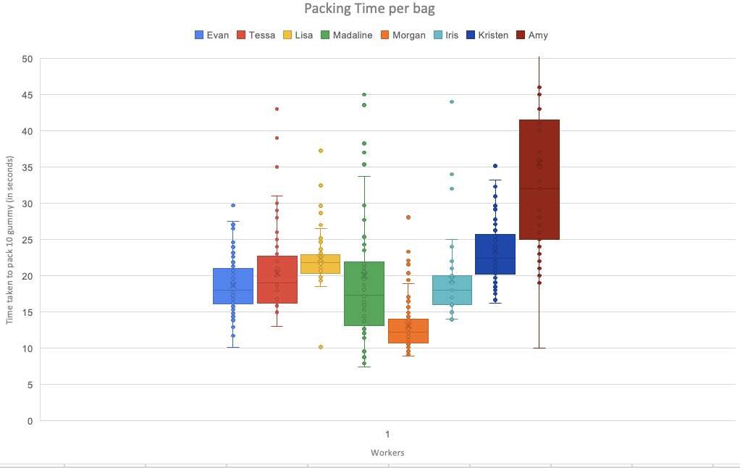
Figure 1.1

Worker Analysis in figure 1.1
- Fastest & Most Consistent Packers:
  - Morgan (orange) had the lowest median packing time (~12 seconds) and a very tight spread, making her the most efficient and reliable packer.
  - Madaline (green) also performed well with a low median and minimal variation, close behind Morgan.
- Moderate Performers:
  - Evan, Tessa, Lisa, and Iris all had median times in the 18–23 second range, with relatively moderate spread, suggesting steady performance.
- Slower Packers:
  - Kristen and Amy had the highest median times, with Amy’s around 33 seconds and Kristen’s slightly below that. Amy also showed a wide IQR, indicating inconsistency.
- Outliers:
  - Several workers (e.g., Amy, Madaline, Lisa) had outliers, but in Amy’s case, it was more frequent and toward the slower end, potentially affecting overall productivity.

The image below shows the final output of this packing process: a transparent bin filled with neatly stickered, pouches of Ayrloom gummies. These bins are stacked on top of one another and placed on a worktable, ready to be moved to the sealing or boxing stage. This snapshot visually captures the result of manual labor and highlights the need for organized and ergonomic handling as the volume continues to grow.
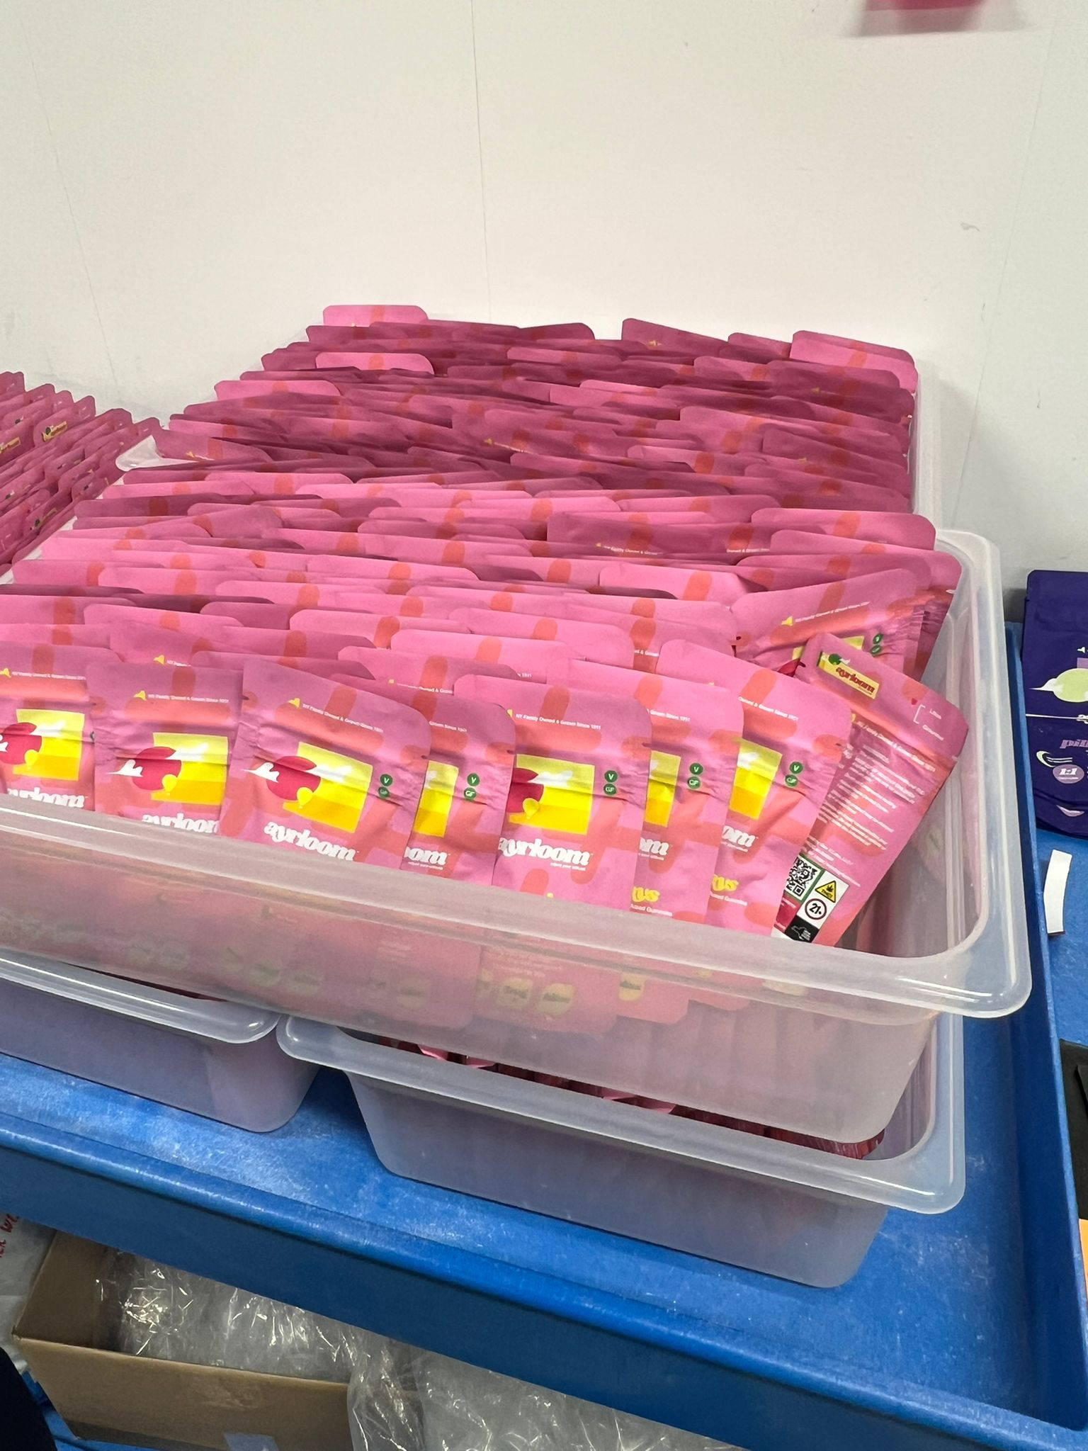

3.2 Cleaning Time Observations
Cleaning involves retrieving a full bin of gummies directly from cold storage. These gummies, especially sour varieties, are visibly sticky and frequently coated in excess sugar or debris, as seen in the image of unclean gummies stored on metal trays. These trays are housed in storage racks and hold multiple layers of freshly made gummies awaiting the cleaning stage.
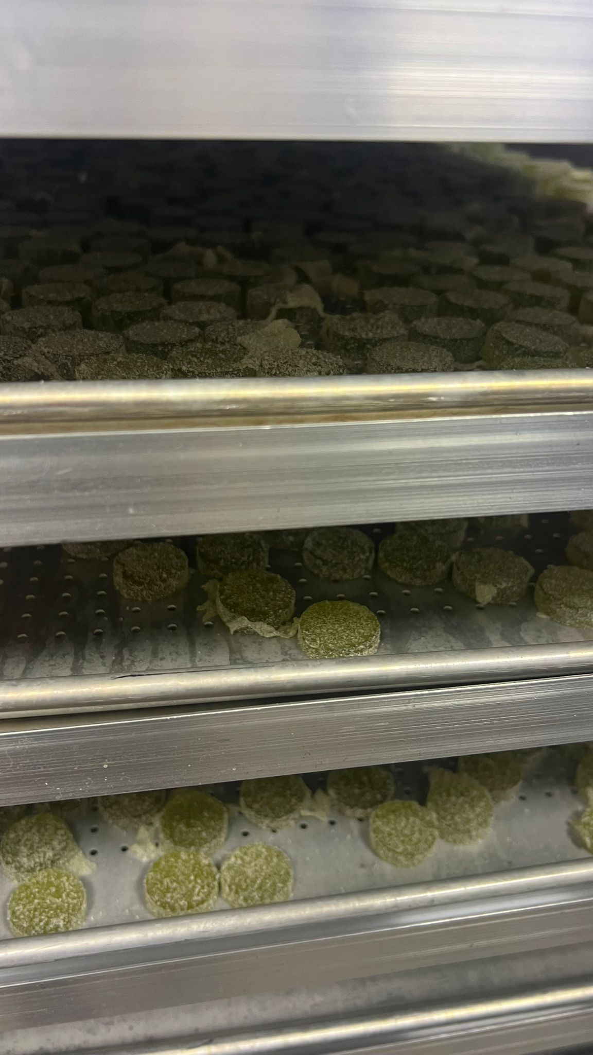
The debris, clumps, and sugar accumulation make manual cleaning both necessary and time-consuming, highlighting the challenge of maintaining quality while meeting speed expectations.
Each gummy must be manually inspected and wiped clean. Workers use their hands to remove surface moisture or sugary clumps. If a gummy is visibly defective (e.g., misshaped, torn, fused, or overly sticky), it is removed and placed into a "defective" bin for rework or disposal. This inspection and wiping process varies widely among employees.
The cleaning process is currently performed without any formalized tools or SOPs, though some use of plastic scoops or trays was observed. Ana delivered the best performance, averaging under 20 seconds per 10-gummy batch. Conversely, Amy's cleaning time frequently exceeded 80 seconds per batch. This more than 4x time discrepancy between workers introduces a significant throughput constraint.
Such extreme variation reduces predictability in shift scheduling and adds pressure on downstream processes like packing and sealing. From our time studies and visual observations, it is evident that cleaning is not only the most inconsistent task but also the largest contributor to packaging delays and system-wide bottlenecks.
Cleaning involves retrieving a full bin of gummies directly from cold storage. These gummies, often sticky—especially in the case of sour varieties—must be manually inspected and wiped clean. Each worker uses their hands to remove surface moisture or residue. If a gummy is visibly defective (e.g., misshaped, torn, or fused to another), it is separated and placed into a "defective" bin for rework or disposal.
This process is performed manually and without a formalized tool, though some use of plastic scoops and trays was observed. Despite the seeming simplicity of this task, it proved to be the most time-consuming and inconsistent. Ana delivered the best performance, averaging under 20 seconds per 10-gummy cleaning batch. Amy, however, often exceeded 80 seconds per batch.
This extreme variation not only drags down average throughput but also introduces uncertainty in scheduling and planning. It was evident from our data that the cleaning step is the largest contributor to bottlenecks in the system.

3.3 Stickering Performance
Once packaging pouches are ready, they must be labeled with compliance and product information stickers. This is done manually. Workers receive sticker sheets—each sheet containing 154 pre-printed adhesive stickers. Using their hands, they peel off each sticker and carefully apply it to a flat area on the pouch, specifically to the right of the barcode.
The image below illustrates an example of un-stickered packaging pouches, stacked neatly and ready to be labeled. The designated space for sticker placement—next to the barcode—is critical for regulatory compliance and product traceability. Since stickers include essential information like QR codes, batch IDs, THC content, and warning labels, accurate and consistent placement is essential.
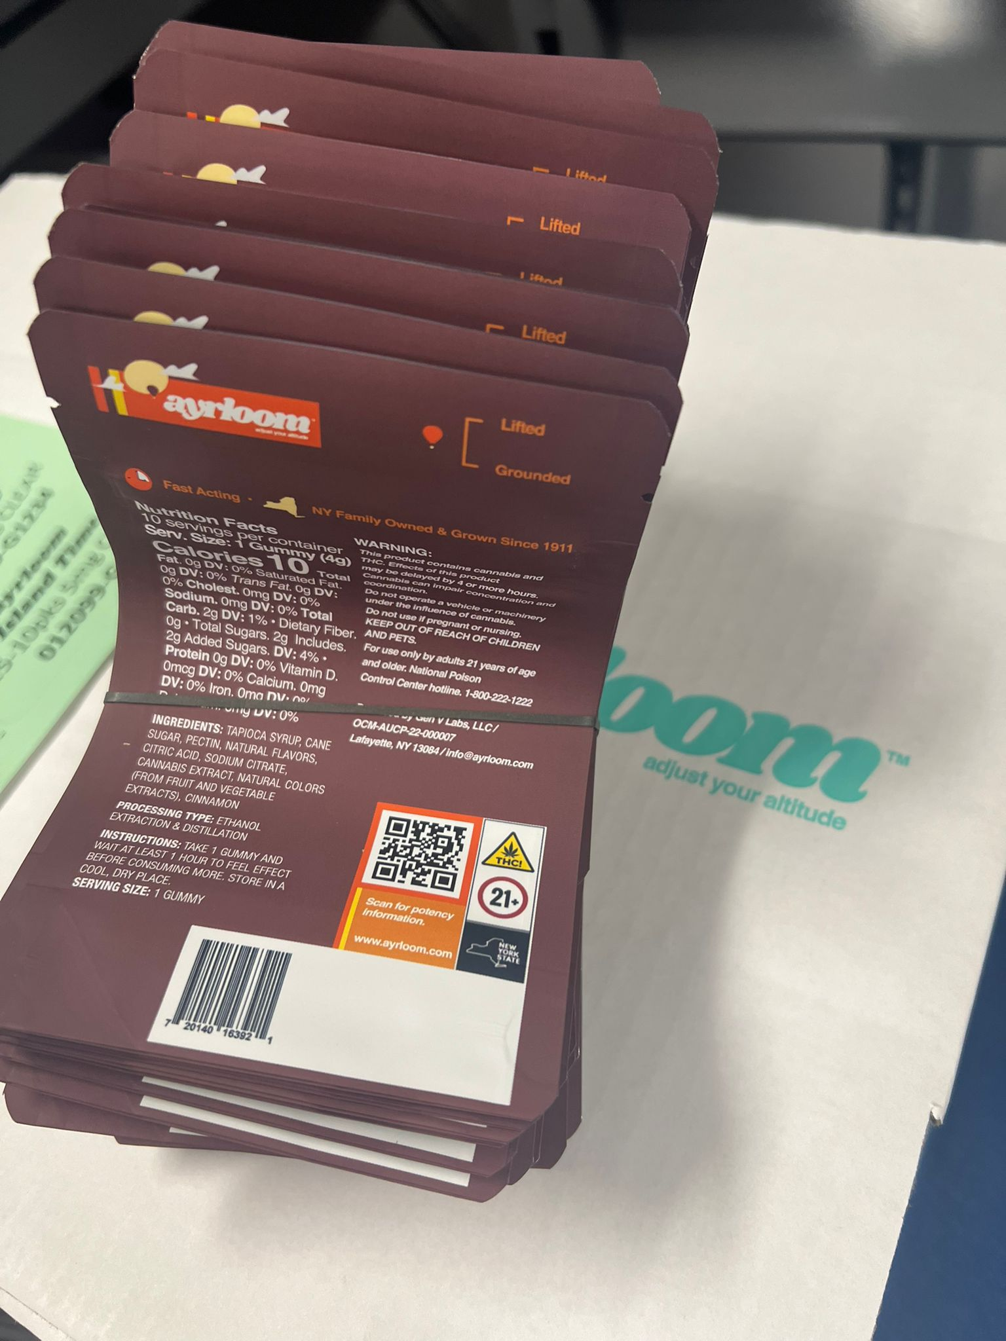
In the "Stickering" data, we analyzed Anna’s performance across three recorded sessions. She applied 154 stickers in just under 10 minutes, averaging approximately 3.5 seconds per sticker. This task, while repetitive, showed minimal variation and posed no significant constraint in the overall process.
Nonetheless, stickering represents an ideal task for support role delegation. It is best assigned to workers with slower packing or cleaning times so that higher-performing individuals can remain focused on bottlenecked tasks. The clarity of sticker placement also contributes to product presentation and customer trust, reinforcing the importance of training and visual quality checks even for this seemingly minor step.
Once packaging pouches are ready, they must be labeled with compliance and product information stickers. This is done manually. Workers receive sticker sheets—each sheet containing 154 pre-printed adhesive stickers. Using their hands, they peel off each sticker and carefully apply it to a flat area on the pouch.
In the "Stickering" data, we analyzed Anna’s performance across three recorded sessions. She applied 154 stickers in just under 10 minutes, averaging approximately 3.5 seconds per sticker. This task, while repetitive, showed minimal variation and posed no significant constraint in the overall process. Nonetheless, it represents an ideal task for support role delegation, relieving high performers from non-bottleneck work.

4. Root Cause Analysis
Root cause analysis is essential in the Analyze phase to diagnose the true underlying reasons for the problems observed in the process. While symptoms such as "slow packaging" or "low throughput" are visible on the surface, Lean Six Sigma emphasizes drilling deeper to reveal what causes these issues. To conduct this investigation, we used two widely recognized tools: the Fishbone Diagram (Ishikawa) and the 5 Whys Analysis. These tools not only helped visualize the relationship between potential causes and the problem but also guided our team in distinguishing between root causes and superficial ones.

4.1 Fishbone (Ishikawa) Diagram
A Fishbone Diagram, also known as a cause-and-effect diagram, is a visual tool that categorizes potential causes of problems into logical groupings. In our case, the main problem or effect was defined as "Packing Productivity Below Target."
We identified and grouped contributing factors into six key categories:
- Manpower: Workers operate at drastically different speeds; some are extremely fast and consistent, while others are slow and erratic. Training is informal, and many new employees learn by shadowing rather than with standardized procedures.
- Methods: There are no standard operating procedures (SOPs) for tasks like cleaning, stickering, or handling sour gummies. As a result, workers develop their own habits, leading to high process variation. One significant but currently out-of-scope contributor is the way gummy slurry is poured into molds in the kitchen. Instead of using automated nozzles to fill each mold cavity directly, the slurry is poured manually in bulk and spread by scrapper. This uneven distribution leads to clumped, misshapen, or sticky gummies that require more intensive manual cleaning downstream. While this upstream step was not part of our formal project scope, its impact on the cleaning workload was noted during our observations.
- Machines: Manual sealing adds time and is inconsistent. Manual processes dominate several tasks in the packaging workflow. For example, the use of basic tools or bare hands for cleaning, combined with manual handling of trays and packaging materials, increases fatigue and variation. There is a lack of ergonomic equipment to support repetitive actions, such as cleaning or transferring gummies.
- Materials: Sour gummies are sticky and take longer to clean. Additionally, packaging materials such as stickers are handled manually and fetched individually rather than being organized in advance.
- Measurements: Time tracking is limited. Workers are not consistently monitored, and no benchmarks or KPIs are posted to set expectations or encourage goal setting.
- Environment: The packaging room lacks an efficient layout. Workers must walk to collect gloves, bins, stickers, and cleaned items. This unnecessary motion contributes to lost time and confusion.
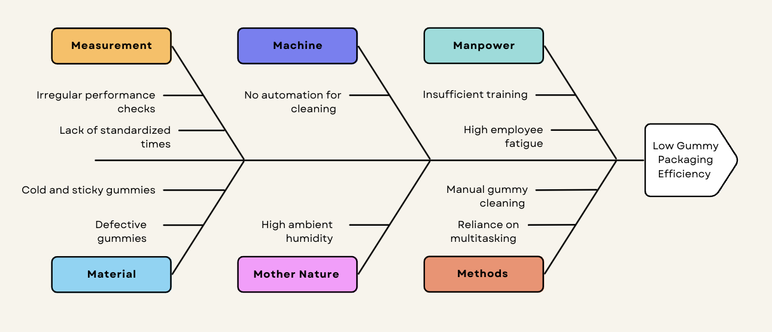
This diagram provided a structured way to brainstorm all potential root causes and enabled the team to identify recurring patterns across tasks and roles.

4.2 5 Whys Analysis
To further understand the inconsistency in cleaning performance, we applied the 5 Whys analysis. This method is used to drill down from the symptoms of a problem to its root cause by asking "Why?" iteratively.
Problem Statement: Cleaning times vary greatly across workers, leading to inconsistent throughput and delays in downstream processes.
- Why 1: Because some workers take significantly longer to clean gummies than others.
- Why 2: Because each worker uses a different method for cleaning, with no standardization in the tools or techniques used.
- Why 3: Because there are no documented standard operating procedures (SOPs) or visual job aids that define a preferred method.
- Why 4: Because cleaning was treated as an extra task rather than a core activity during packaging process design.
- Why 5: Because the initial focus of the packaging operation was on maximizing output to meet growing product demand, and less attention was given to designing structured, replicable processes for non-automated steps.
This refined analysis shows that inconsistency in cleaning performance stems not just from individual skill, but from systemic gaps in training and process definition. By treating cleaning as a value-added core function — and not merely a prep step — the organization can set up training systems, feedback loops, and performance expectations that reduce variation and boost overall efficiency. This exercise revealed that while surface-level inefficiencies like "slow cleaning" exist, the root causes often stem from poor training infrastructure and lack of process standardization. By addressing these foundational issues, the team can ensure that improvements are sustainable over time.

5. Pareto Analysis
To further refine our root cause insights, we used the Pareto Principle also known as the 80/20 rule which suggests that 80% of consequences come from 20% of causes. In our context, we aimed to identify the most frequent and impactful causes of delays during gummy packaging operations.
Our data-driven Pareto analysis revealed that three specific factors were responsible for most of the inefficiencies:
- Cleaning Process Bottlenecks (~43%)
  - Time studies showed that the slowest cleaner (Amy) averaged over 80 seconds per batch, while the fastest (Ana) averaged under 20 seconds. This 4x variability in execution time created long queues between cleaning and packing stages. Sour gummies added extra cleaning time due to their stickiness. On average, a single batch of 10 gummies took 32–50 seconds to clean, contributing to significant delays.
- Worker Movement to Fetch Materials (~27%)
  - Workers routinely left their stations to get gloves, stickers, clean bins, and labeled packaging. In a single 10-minute observation, some workers spent over 2.5 minutes walking or waiting for resources. This loss of continuity and repeated interruption in flow significantly reduced effective labor utilization.
- Sealing and Packaging Variability (~18%)
  - Manual sealing is slower, with throughput varying between 35 and 60 bags per hour depending on the operator. The automatic sealer, though available, was rarely used due to lack of training. Also, sealing errors occasionally required resealing or re-packing, increasing rework.
The remaining causes including sticker misalignment, labeling errors, and inconsistent bin organization accounted for less than 12% of total delays combined.

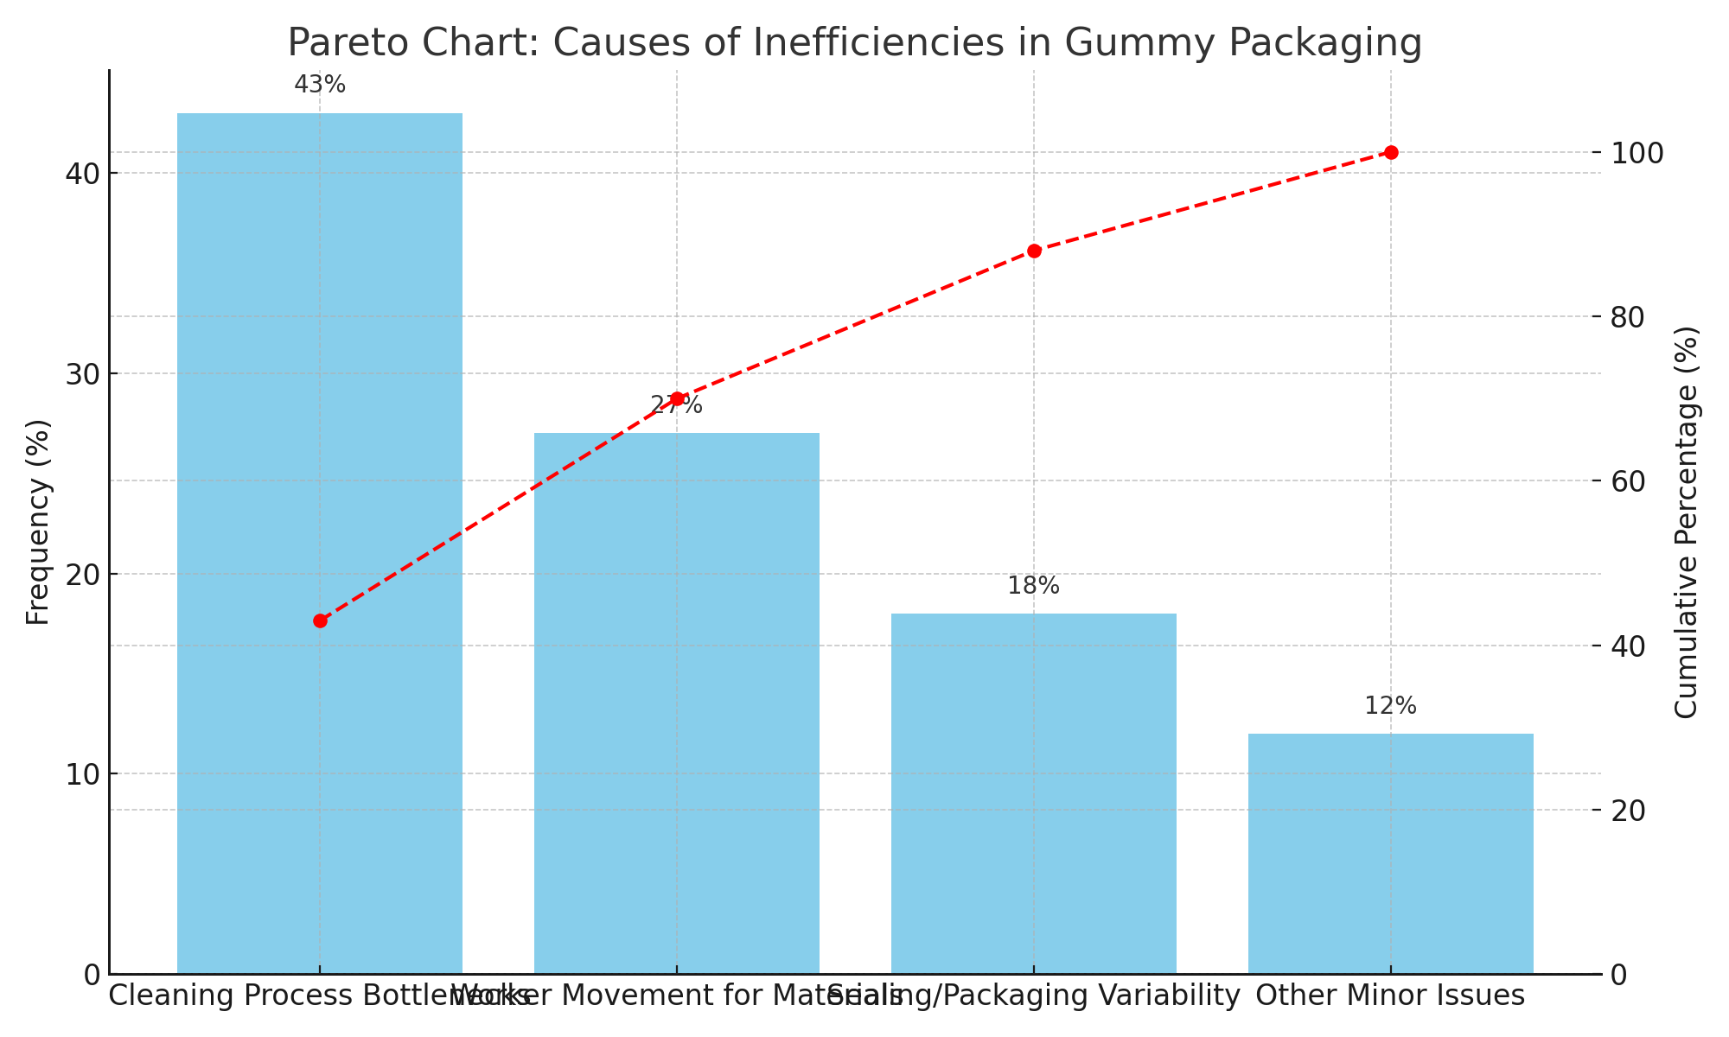
The visual Pareto chart confirmed that focusing improvement efforts on cleaning SOPs, centralized material supply via a runner, and proper use of sealing equipment would eliminate most of the recurring inefficiencies. Addressing just these top three categories is expected to yield a 50–60% increase in packaging line efficiency.
A Pareto Chart revealed that the top three contributors to inefficiencies were:
- Cleaning Process Bottlenecks
- Worker Movement to Fetch Materials
- Sealing/Packaging Variance by Operator
These three categories accounted for over 80% of total delays observed. The Pareto approach allowed us to prioritize improvement efforts with high ROI.

6. Layout and Flow Analysis (Spaghetti Diagram)
Efficient layout and workflow are foundational principles in Lean manufacturing. At Ayrloom, we identified that poor spatial organization and excessive motion were significantly contributing to the inefficiencies within the packaging process. Our direct observations, interviews, and spaghetti diagram analysis revealed that workers frequently left their stations during operations whether to collect gloves, retrieve clean bins, find sticker sheets, or carry sealed pouches to the next area. These unnecessary motions introduce wasted time, disrupt workflow, and cause bottlenecks.
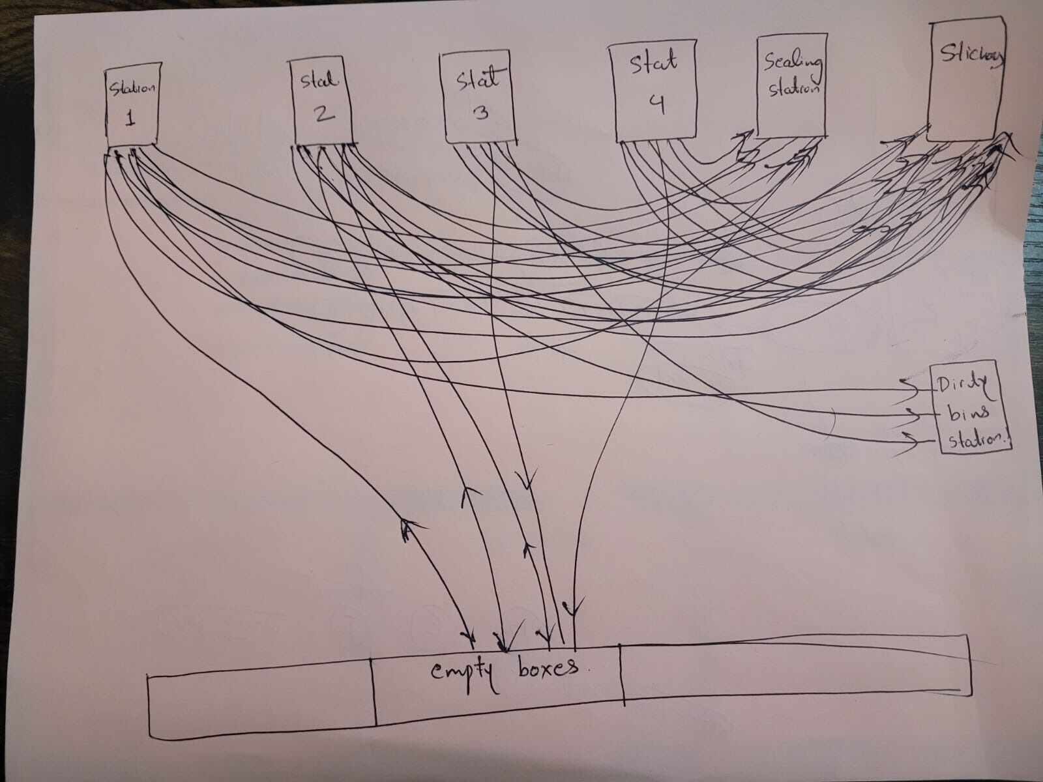
The spaghetti diagram of the current packaging area highlights an erratic, non-linear flow of people and materials. The movement paths of employees intersect repeatedly across various stations (from Station 1 to Sticker and Sealing), indicating frequent backtracking and role switching. Several flow lines overlap in the center of the room, demonstrating congestion and redundant paths between racks, tables, and work areas. Shared access to dirty box tables and supply racks contributes to collisions in workflow.
Specific observations include:
- Workers routinely walk 6–18 feet between task zones (based on distance markings on the layout).
- All stations access the same bins, tables, and racks, causing overlap and delays.
- The current flow does not follow a logical path such as U-shaped or straight-line assembly, increasing the cognitive load and variability.
- No clear spatial division exists between cleaning, packing, and sealing zones.
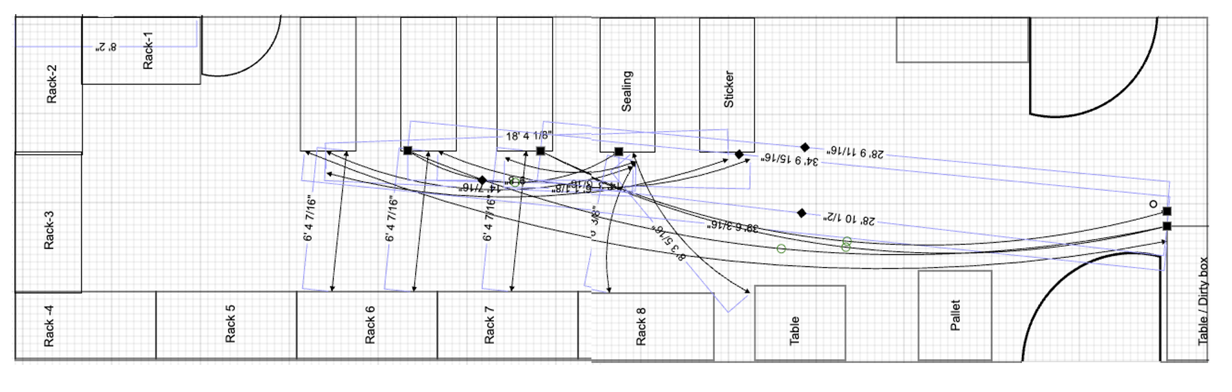
To address these issues, we recommend the following redesign elements:
- Dedicated Stations by Function: Implement strict separation of cleaning, packing, sealing, and boxing stations, with each equipped with its own supply stock.
- Central Supply and Dirty bin Zones: Relocate supplies and waste collection points to the periphery, ensuring minimal interference with the primary workflow.
- Introduce a Runner Role: This individual ensures material replenishment and waste clearing, keeping packers and cleaners focused on task execution.
- Establish a Linear or U-Shaped Layout: Redesign flow from left to right (or U-shaped) so that workers and materials progress in a single direction with no backtracking.
- Use Visual Controls: Apply colored floor tape and workstation signage to clearly indicate roles, routes, and boundaries for movement.
From our evaluation, these changes are expected to reduce motion waste by 15–25% and improve task clarity, especially for new employees. Implementing a Lean-aligned layout is critical for scaling the packaging process while maintaining consistency and speed.
Efficient layout and workflow are foundational principles in Lean manufacturing. At Ayrloom, we identified that poor spatial organization and excessive motion were significantly contributing to the inefficiencies within the packaging process. Our direct observations and interviews revealed that workers frequently left their stations during operations — whether to collect gloves, retrieve clean bins, find sticker sheets, or carry sealed pouches to the next area. These unnecessary motions introduce wasted time, disrupt workflow, and cause bottlenecks.
For example, during a standard 10-minute observation of the packaging floor, one worker spent over 3 minutes simply walking between tasks or waiting for materials to arrive. When this behavior is scaled across multiple shifts and workers, the cumulative motion waste becomes a significant drag on productivity. Moreover, many resources (like sticker sheets, gloves, and boxes) are not centrally located, causing interruptions even in high-performing workers' routines.
To address this, we conducted a detailed process walk and mapped the physical flow of materials and personnel across the current layout. This was compared with ideal Lean principles, which emphasize minimizing motion, creating clear stations for each task, and enabling smooth transitions between sequential activities.
As a result, we propose the following redesign elements:
- Designated Cleaning, Packing, and Sealing Zones: Each zone should have its own supplies and dedicated bins, preventing cross-traffic and confusion.
- Centralized Material Cart with a Dedicated Runner: A runner will be responsible for stocking sticker sheets, gloves, clean bins, and retrieving filled boxes. This ensures that core packaging staff remain focused on their primary task without leaving their stations.
- One-Way Process Flow: Layout should follow a U-shaped or straight-line design from cleaning → packing → sealing → boxing. This eliminates backtracking and prevents workers from crossing paths.
- Visual Cues and Labeling: Floor tape, signs, and standardized workstations should be implemented to define zones, tool locations, and finished goods areas.
By improving the physical environment, Ayrloom can reduce motion waste by an estimated 15–20%, based on industry benchmarks. Combined with proper task allocation, these changes will lead to a smoother, faster, and more scalable packaging operation.
We observed significant motion waste due to workers leaving their stations frequently—to collect stickers, bring gloves, fetch new bins, or move sealed pouches. The current packaging room lacks a standardized layout, creating unnecessary travel and slowing down work.

A revised layout plan that incorporates a centralized runner, designated sticker station, and linear flow between tasks will reduce non-value-added motion and streamline throughput.

7. Worker Performance Ranking
The worker time study conducted as part of the Analyze Phase revealed significant differences in task execution speeds across employees. To ensure process efficiency and maximize throughput, aligning tasks to each worker’s strengths is essential.
Below is a detailed performance table compiled from observational data for packing, cleaning, and stickering tasks:
Worker | Avg. Packing Time (secs) | Avg. Cleaning Time (secs) | Stickering Time (sec/sticker) | Suggested Roles
Morgan | 10.5 | 14.9 | - | Core Packing
Ana | - | 19.5 | - | Core Cleaning
Iris | 14.0 | 24.3 | - | Support Packing
Tessa | 20.5 | 32.1 | - | Support Packing
Evan | 22.1 | 35.0 | - | Support Cleaning
Kristen | 30.2 | 49.8 | - | Stickering/Support
Amy | 45.6 | 81.2 | 3.5 | Stickering/Support

Key Observations:
- Morgan is the most efficient packer with an average of 10.5 seconds per bag and should be dedicated to high-speed packing roles.
- Ana consistently delivered the best cleaning times (19.5 seconds per batch), making her a great fit for dedicated cleaning tasks.
- Amy had the highest variability and longest times in both packing and cleaning but demonstrated consistency in stickering (~3.5 seconds per label), suggesting her ideal role is in supportive tasks like labeling and boxing.
- Kristen, while slower in manual work, may be more effective in standardized, repetitive work like labeling.
By leveraging this data, we propose a performance-based work allocation strategy where:
- Top performers focus on value-generating core tasks.
- Moderate performers assist with preparation, rework, and boxing.
- Lower-performing individuals are placed in roles that require consistency over speed (e.g., stickering).
This division of labor will reduce cycle time variation, minimize errors, and create a more balanced workload across the team, aligning well with Lean principles of waste reduction and role clarity.
Based on average cycle time across tasks:
- Top Performers: Morgan, Ana, Iris
- Moderate Performers: Tessa, Evan
- Low Performers: Amy, Kristen

Assigning roles based on this ranking allows for specialization. High performers can focus on core tasks like packing and cleaning, while others support with stickering or boxing.
8. Summary of Findings
The findings from the Analyze Phase provide critical insight into the underlying inefficiencies within Ayrloom’s packaging workflow. By triangulating quantitative time study data, qualitative floor observations, and root cause tools like Fishbone and Pareto, we observed the following key issues:
- Cleaning as the Primary Bottleneck: Cleaning operations have the highest cycle time and variability across all packaging activities. The slowest worker takes up to 80 seconds per 10-gummy batch, compared to the fastest at under 20 seconds. This gap leads to queueing delays and underutilization of packers.
- Worker Speed Variation: There is a 4x difference in task execution speed between top and bottom performers. Inconsistent performance leads to erratic daily output and makes it difficult to meet scaling demand.
- Manual and Redundant Processes: All major tasks — cleaning, packing, sealing, and stickering — are performed manually. Motion studies show significant time wasted on non-value-added steps, such as retrieving supplies or backtracking across the room.
- Lack of Visual Standards and SOPs: There are no documented standard operating procedures or visual work instructions posted in workstations. New workers learn by watching others, which increases variability and risk of error.
- Non-Optimized Floor Layout: The current layout lacks flow logic. Movement overlaps, congestion, and supply station ambiguity increase motion waste and slow down transitions between tasks.
- Underutilized Equipment: Although an automatic sealing machine exists, it is rarely used due to lack of training. Manual sealing increases variability and operator fatigue.
These findings serve as the bedrock for developing targeted improvement solutions that align with Lean Six Sigma principles of waste reduction, role clarity, and standardized processes.
- Cleaning is the dominant bottleneck
- Worker speed varies 2–4x across roles
- Manual processes and movement waste slow the system
- Visual SOPs and training are lacking
- No standardized packaging layout or material flow exists

9. Recommendations from Analyze Phase
Based on our in-depth analysis, we propose the following high-impact recommendations to improve packaging efficiency at Ayrloom. These solutions are rooted in our findings from time studies, spaghetti diagrams, and task audits.
- Task Reallocation Based on Performance
  - Assign faster workers (e.g., Morgan, Ana) to core cleaning and packing stations.
  - Redirect slower but consistent workers (e.g., Amy, Kristen) to sticker application, boxing, and supportive logistics roles.
  - Rotate moderately performing workers across tasks to build flexibility without slowing core lines.
- Implement SOPs and Visual Aids for Cleaning and Packing
  - Develop standardized steps with visuals for cleaning different gummy types (regular vs. sour).
  - Introduce visual checklists at each station to ensure consistency in method and timing.
  - Train new workers using shadowing + checklist walk-through.
- Introduce Dedicated Runner Role
  - Assign one support worker per shift to manage material logistics (stickers, boxes, gloves, bins).
  - The runner will prevent motion waste and allow cleaners/packers to stay focused on core tasks.
- Redesign Floor Layout to Support Lean Flow
  - Implement a linear or U-shaped workflow: cleaning → packing → sealing → boxing.
  - Centralize supplies and create isolated stations to eliminate crisscrossing paths.
  - Add visual controls such as taped zones and labeled racks.
- Use Time Studies to Benchmark and Motivate
  - Display average times per task and per worker as internal metrics.
  - Set achievable targets for each role and reward performance with verbal recognition or small incentives.
- Utilize Automatic Sealer to Reduce Bottlenecks
  - Train 2–3 employees on consistent use of the automatic sealer.
  - Use automatic sealing as the default for high-volume batches, reserving manual sealing only for rework or small runs.
These six recommendations are practical, low-cost, and highly impactful. They are designed not only to improve throughput, but also to boost worker morale, reduce rework, and build a foundation for sustained scalability.
- Task Reallocation Based on Performance
- Implement SOPs and Visual Aids for Cleaning
- Introduce Dedicated Runner Role
- Redesign Floor Layout to Reduce Motion Waste
- Use Time Studies to Benchmark and Motivate
- Utilize Automatic Sealer to Standardize Output

10. Conclusion
The Analyze Phase confirmed that while Ayrloom’s workforce is dedicated and capable, systemic inefficiencies in layout, training, and task distribution limit overall throughput. Our investigation revealed that cleaning is the dominant constraint, exacerbated by variability in worker speeds and a lack of standardization in daily operations. Furthermore, excessive movement between stations and underuse of available automation introduce avoidable delays.
By using Lean Six Sigma tools such as the Fishbone Diagram, Pareto Analysis, and Spaghetti Mapping, we were able to visualize and validate the specific areas causing performance drops. Data from detailed time studies further reinforced the need for a role-based assignment strategy and better layout configuration.
The recommendations derived from this analysis are not just theoretical — they are practical, measurable, and achievable. Implementing these changes will yield:
- Increased consistency in output
- Better use of skilled labor
- Reduction in downtime and walking waste
- Enhanced onboarding process through SOPs
- Greater alignment between packaging capacity and rising production volumes
With these insights in place, the Improve Phase can now be targeted with confidence. This phase will focus on testing, validating, and scaling the proposed interventions — ensuring that the changes we recommend translate into real-world performance gains for Ayrloom’s packaging team.
The Analyze Phase validated our hypothesis that the biggest constraints at Ayrloom lie in process variation and inefficient task allocation. By using data, observational insights, and structured problem-solving tools, we were able to uncover the drivers of delay and inconsistencies in throughput. The findings provide a clear foundation to develop and implement impactful solutions in the Improve phase.

